Current Network Setup - Fedora Server

Server Type: Fedora
Student Name: Gabriel Moreira

How Networking Works on This Server by Default
This Fedora server uses NetworkManager as its primary network management service, running continuously in the background to manage all network connections. By default, network interfaces are configured to obtain IP addresses automatically via DHCP from the network's DHCP server (usually my router).

Unlike older Linux distributions, Fedora stores NetworkManager connection profiles in /etc/NetworkManager/system-connections/ as .nmconnection files rather than traditional interface configuration files. The server uses predictable network interface names (such as enp0s3 for Ethernet or wlp2s0 for wireless), ensuring consistent device naming across reboots. DNS resolution may be handled by either NetworkManager directly or through systemd-resolved, with /etc/resolv.conf often being a symbolic link to the active DNS configuration. An important default security feature is that firewalld runs automatically and blocks incoming connections unless explicitly allowed.

To find all relevant network information on this server, I use commands like ip addr show to view interfaces and IP addresses, nmcli connection show to see all configured connections, ip route show to check routing, and firewall-cmd --list-all to view firewall rules. All custom network scripts I've created are stored in /home/gabe/scripts/, configuration files are in /etc/NetworkManager/system-connections/, and the primary management tool is nmcli for controlling NetworkManager connections from the command line.

Current Network Configuration

To view the my current network configuration at anytime, run the command below
Command: ip addr show
Output:
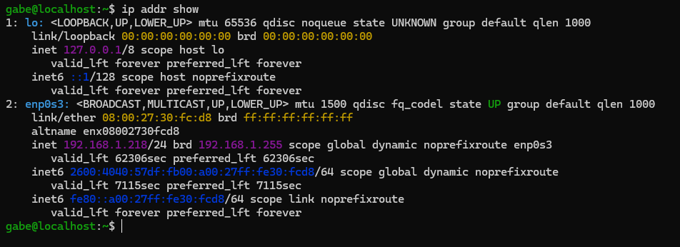
Configuration Type: [DHCP]

Gateway and Routing
To show the routing information use the command below
Command: ip route show
Output: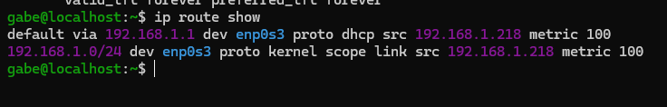
Default Gateway: 192.168.1.1

DNS Configuration
To view the current DNS configuration, run the command below
Command: cat /etc/resolv.conf
Output: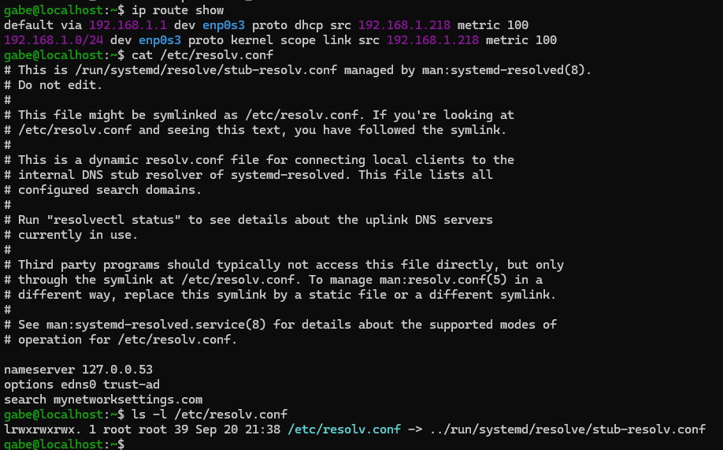

DNS Management:
My DNS is resolved by system, the command to view is shown below
Command: resolvectl status
Output:
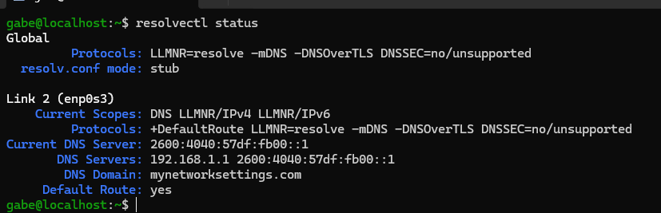

NetworkManager Status
At the time of writing this documentation, this was my network manger’s status shown in the output below. Run the command to replicate.
Command: systemctl status NetworkManager
Output: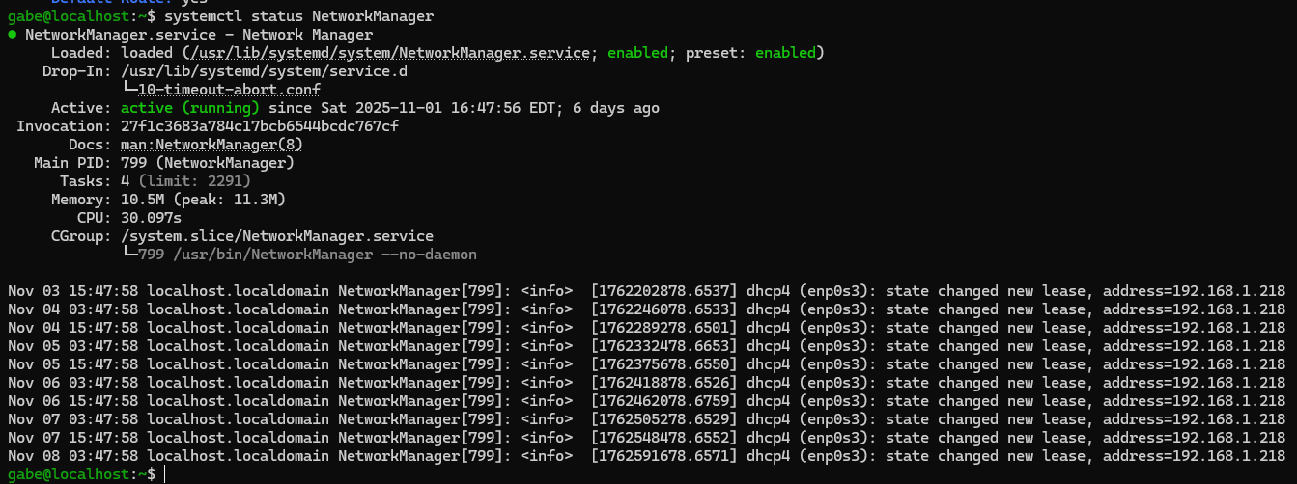

Service Status: [Active]

Firewall Configuration
To view the firewall configuration, run the command below, I have also provided a sample of the expected output.
Command: sudo firewall-cmd --state; sudo firewall-cmd –list-all
Output:
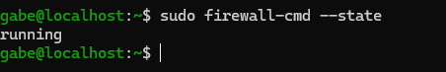
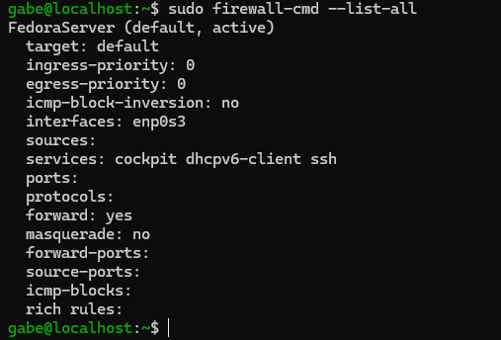

Installed Networking Packages
Here is a list of recent software and package installations on my server
Command: dnf5 history list | head -30, rpm -qa --last | head -20
Output:
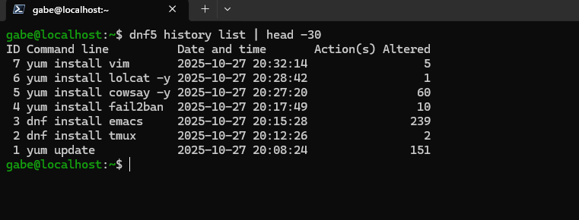
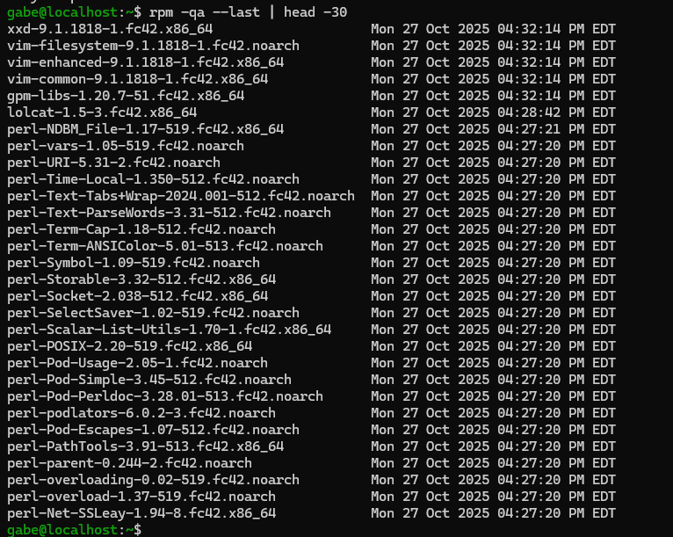

System Updates
Command: sudo dnf update -y
Output:
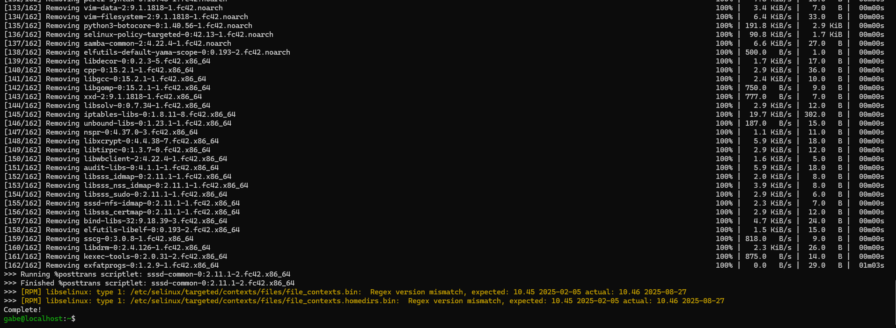
Last Full System Update: [Date: 2025-11-09]

Location of Network Information
Configuration Files

Type | Location | Purpose
NetworkManager Connections | /etc/NetworkManager/system-connections/ | Modern connection profiles (.nmconnection files)  In my case enp0s3.nmconnection
DNS Configuration | /etc/resolv.conf | DNS resolver settings
Hostname | /etc/hostname | System hostname
Host Mappings | /etc/hosts | Static IP-to-hostname mappings
Firewall Config | /etc/firewalld | Firewall zones and rules

Custom Scripts

Script Name | Location | Purpose
network_info_dump.sh | /home/gabe/scripts/ | Collects comprehensive network info to file
network_troubleshoot.sh | /home/gabe/scripts/ | Interactive troubleshooting guide

